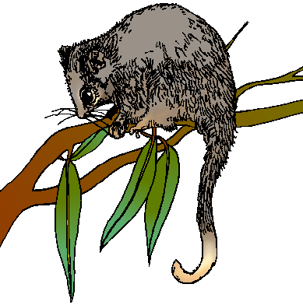

### Rosanna Cub Scouts

**Activity:** Possum Prowl

**When:** Tues20th June, 2017

**Start Time:** Arrive **6:45pm** – need to make arrangements and tour starts at 7 sharp

**Finish Time:** 8.30pm

**Cost: Free this time!** (money left over from previous activities)



**Where:** La Trobe University

Wildlife Reserve

**Meet at:**

Wildlife Reserve Office – enter from

LaTrobe Ave (between Main Dve

and Ring Rd – <https://goo.gl/maps/n9o1GvyGFv32> )

**Don’t be late…** call 0411 121 495 if

any problems.

**What to wear:**

Cub Uniform

Solid Footwear for walking

Dress for warmth and bring a coat if necessary, waterproof gear if raining

No torch – Adults only (don’t want to affect night vision)

**What we will see:**

Good Question! It depends on two things.

1. How noisy you are!

2. The Weather – if it’s raining, it may STILL be on, so wear waterproof gear and have fun!

A ranger will take us on a guided tour, so we’ll see as much as we can.

**WE NEED TO KNOW NUMBERS ASAP… PLEASE ADVISE AKELA HOW MANY YOU WILL HAVE ATTENDING ON: 0411 121 495 OR akela@rosannacubs.org**

**NOTE: that we have a *cap of 50 people*….With regards to parents/siblings… first in, best dressed after Cubs are included, so don’t delay – please let us know numbers who’d like to go now, and on the night we’ll go up to our limit of 50 in order of first responses**